**OSI Layer Activity**

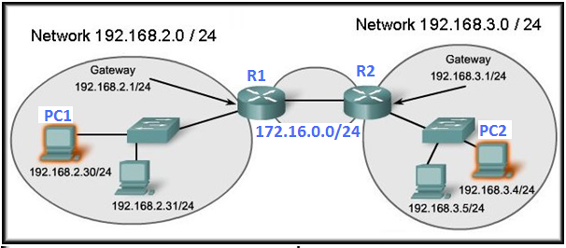

Figure 1:

|  |  |  |
| --- | --- | --- |
| **Device Name** | **IP Address** | **MAC Address** |
| PC1 | 192.168.2.30 | 00-50-56-c0-00-01 |
| PC2 | 192.168.3.4 | 00-5F-AA-BB-00-07 |
| R1_LAN | 192.168.2.1 | BB-AA-CC-DD-00-03 |
| R1_WAN | 172.16.0.1 | BB-AA-CC-DD-00-04 |
| R2_LAN | 192.168.3.1 | DD-CC-AA-11-00-05 |
| R2_WAN | 172.16.0.2 | DD-CC-AA-11-00-06 |

Table 1: MAC addresses and IP addresses of devices interfaces.

Scenario 1: PC1 wants to send a webpage request to a server on PC2. At PC1 what information will need to be inserted at each layer of the OSI model so that information will be sent from PC1 to PC2.

|  |  |  |  |
| --- | --- | --- | --- |
| **Layer** | **Source Application Layer Protocol** | **Destination Application Layer Protocol** |  |
| **Application** |  |  |  |
|  | **Source Port** | **Destination Port** | **Protocol Type** |
| **Transport** |  |  |  |
|  | **Source IP** | **Destination IP** |  |
| **Network** |  |  |  |
|  | **Source MAC** | **Destination MAC** | **Protocol Type** |
| **Date-Link** |  |  |  |

Table 2:

Scenario 2: PC2 wants to send an Email to a server on PC1. At PC2 what information will need to be inserted at each layer of the OSI model so that information will be sent from PC2 to PC1.

|  |  |  |  |
| --- | --- | --- | --- |
| **Layer** | **Source Application Layer Protocol** | **Destination Application Layer Protocol** |  |
| **Application** |  |  |  |
|  | **Source Port** | **Destination Port** | **Protocol Type** |
| **Transport** |  |  |  |
|  | **Source IP** | **Destination IP** |  |
| **Network** |  |  |  |
|  | **Source MAC** | **Destination MAC** | **Protocol Type** |
| **Date-Link** |  |  |  |

Table 3:

Scenario 3: PC 1 wants to send a Telnet request to R2. At R1_WAN interface what information will need to be inserted at each layer of the OSI model so that information will be sent from PC1 to R2.

|  |  |  |  |
| --- | --- | --- | --- |
| **Layer** | **Source Application Layer Protocol** | **Destination Application Layer Protocol** |  |
| **Application** |  |  |  |
|  | **Source Port** | **Destination Port** | **Protocol Type** |
| **Transport** |  |  |  |
|  | **Source IP** | **Destination IP** |  |
| **Network** |  |  |  |
|  | **Source MAC** | **Destination MAC** | **Protocol Type** |
| **Date-Link** |  |  |  |

Example 4: Fill in the Protocol Data Unit (PDU) names for each layer of the OSI model shown in Figure 2 in the blank grey boxes in Figure 2.

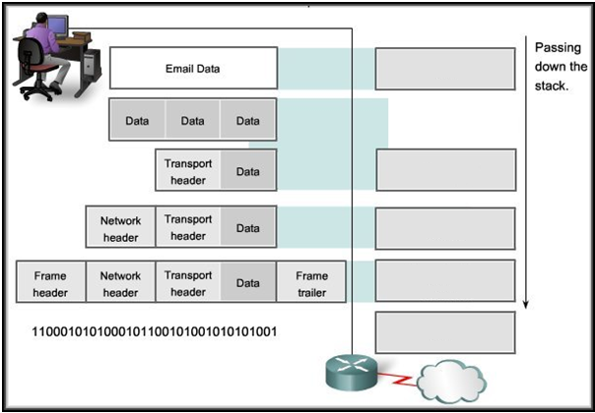

Figure 2: